Pre-Test Test Engineer

Ekaristi Simorangkir

**Basic Programming**

1. What is the data-type usually used in arithmetic operation?

Answer: Data-type usually used in arithmetic operation is **Int**

2. What is the data-type usually used in word and character?

Answer: Data-type usually used in word and character is **Char**

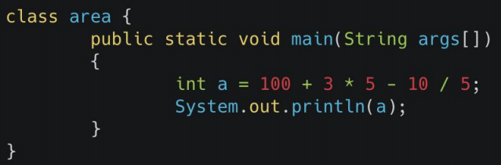3. What is the output of code below:

Answer: 100 + ( 3 * 5) – 10/5=

=100 + 15 - 2 = **113**

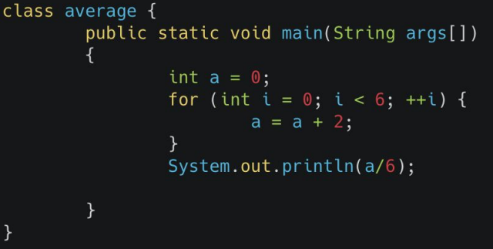4. What is the output of code below:

Answer: the looping process occurred 6 times

a 0 = 0 + 2 = 2

a 1 = 0 + 2 = 2

a 2 = 0 + 2 = 2

a 3 = 0 + 2 = 2

a 4 = 0 + 2 = 2

a 5 = 0 + 2 = 2

Output : 2

If the value of i still meets the requirements of i < 6 then the looping process will continue according to the looping concept that has been inputted. and the expected output is the result of a / 6 then the result is 2.

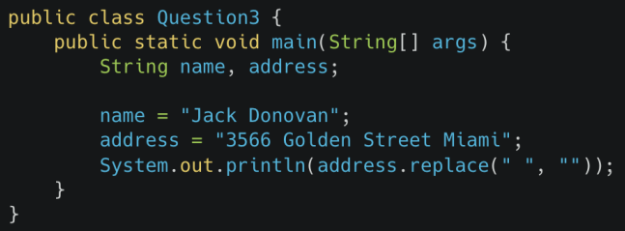5. What is the output of code below:

Answer: 3566GoldenStreetMiami

**Flaky Test**

1. What is a flaky test?

Answer: A Flaky test is an analysis of [web application](https://searchsoftwarequality.techtarget.com/definition/Web-application-Web-app) code that fails to produce the same result each time the same analysis is run. Whenever new [code](https://whatis.techtarget.com/definition/code) is written to develop or update computer [software](https://searchapparchitecture.techtarget.com/definition/software), a web page or an app, it needs to be tested throughout the development process to make sure the application does what it’s supposed to do when it’s released for use. Logically, when put through the same test over and over, the code will produce the same result

2. An element in a website is using ajax/javascript to show the data (processed as asynchronous). What do you do to test tShat element?

Answer: If in a website is using ajax/javascript to show the data, tools for testing, for example using Selenium Webdriver has to use the wait method on this Ajax Call. So by executing this wait command, selenium will suspend the execution of current[Test Case](https://www.guru99.com/test-case.html)and wait for the expected or new value. When the new value or field appears, the suspended test cases will get executed by Selenium Webdriver.

Below is the wait methods that Selenium Webdriver can use:

* Thread.Sleep()
* Implicit Wait()
* Explicit Wait()
* WebdriverWait
* Fluent Wait

But there is Challenges in Handling Ajax Call in Selenium Webdriver

* Using "pause" command for handling Ajax call is not completely reliable. Long pause time makes the test unacceptably slow and increases the Testing time. Instead, "waitforcondition" will be more helpful in testing Ajax applications.
* It is difficult to assess the risk associated with particular Ajax applications
* Given full freedom to developers to modify Ajax application makes the testing process challenging
* Creating automated test request may be difficult for testing tools as such AJAX application often use different encoding or serialization technique to submit POST data.

3. A website page can only be accessed with CAPTCHA. How do you test that page?

Answer:

* Verify that the Application should accept only Valid CAPTCHA.
* Verify that the CAPTCHA code showing on screen is visivble to user or Not.
* Verify that the CAPTCHA code format(Captch should be in Image).
* Verify that the CAPTCHA code reusable or Not .
* Verify that the CAPTCHA code generate new code or not  once the page is get refreshed.
* Verify that the CAPTCHA code generate new code or not once user entered the wrong Captcha
* Verify that the copy paste for CAPTCHA code should be hide .
* Verify that the CAPTCHA code should be Case Sensitivity .(Upper cases and lower case).
* Verify that the CAPTCHA code should not distruot the other fields in the form once entered wrong.
* Verify that the Application should dispaly a alert message when use enter wrong captcha code .
* Verify the audio version of captcha (as per SRS).
* Verify that the CAPTCHA code should not be confusing.
* Verify that the application should not accept the partial CAPTCHA code as valid.
* verify only first and last letter from the captcha Code
* Verify By Entering the correct CAPTCHA code, followed by a random character.

Essay Question Topic

**Essay Question Topic**

1. Create automation test script to test these end-point:

GET -> https://jsonplaceholder.typicode.com/posts -> To make sure this end-point have a correct data-type below:

■ userId -> Integer

■ id -> Integer

■ title -> String

■ body -> String

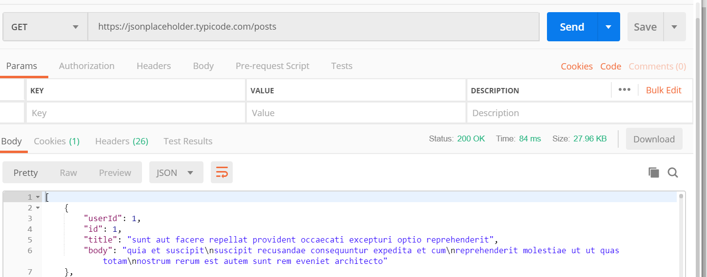

1. POST -> https://jsonplaceholder.typicode.com/posts -> To make sure this end-point get a correct response compare with the input data:

